TDD using JUnit5 and Mockito
3. Mockito exercises
Exercise 1: Mocking and Stubbing
Solution:
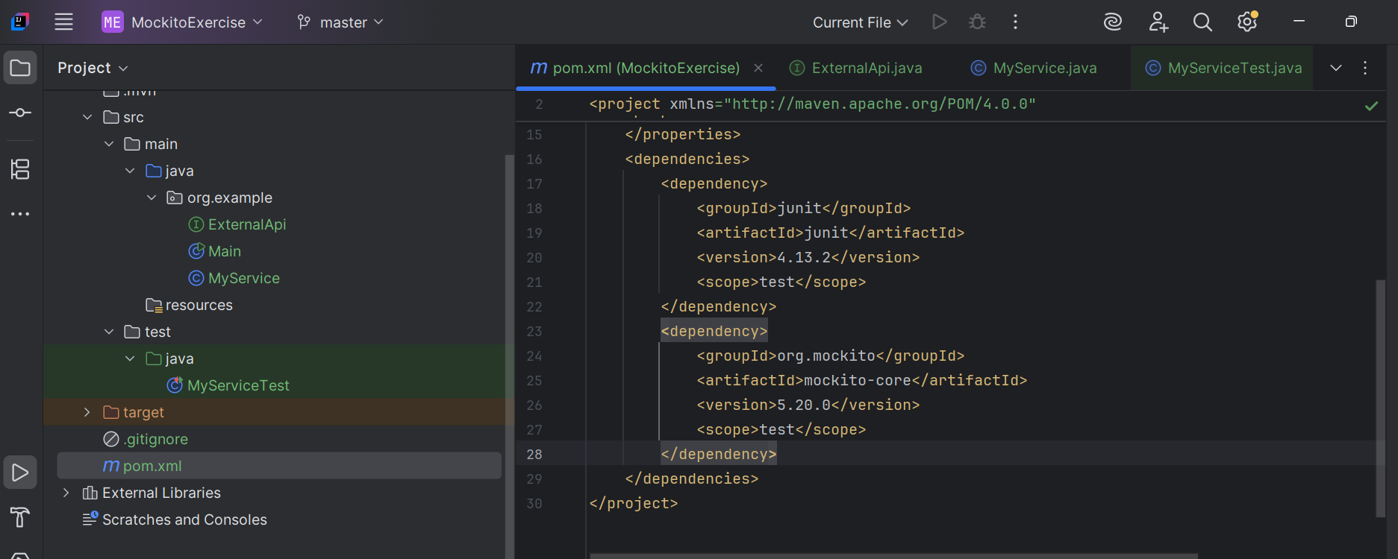
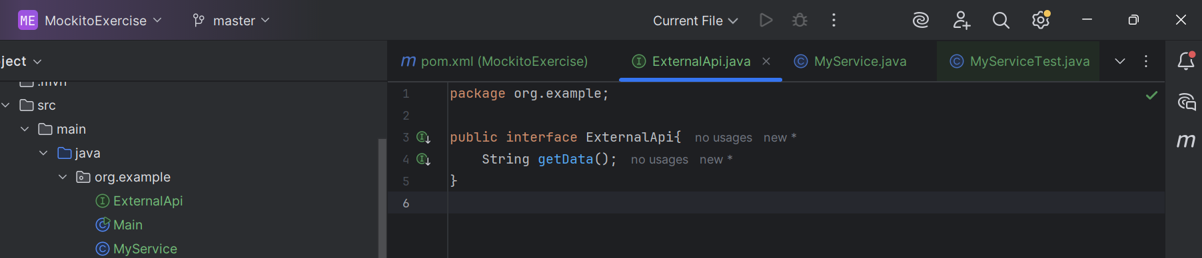
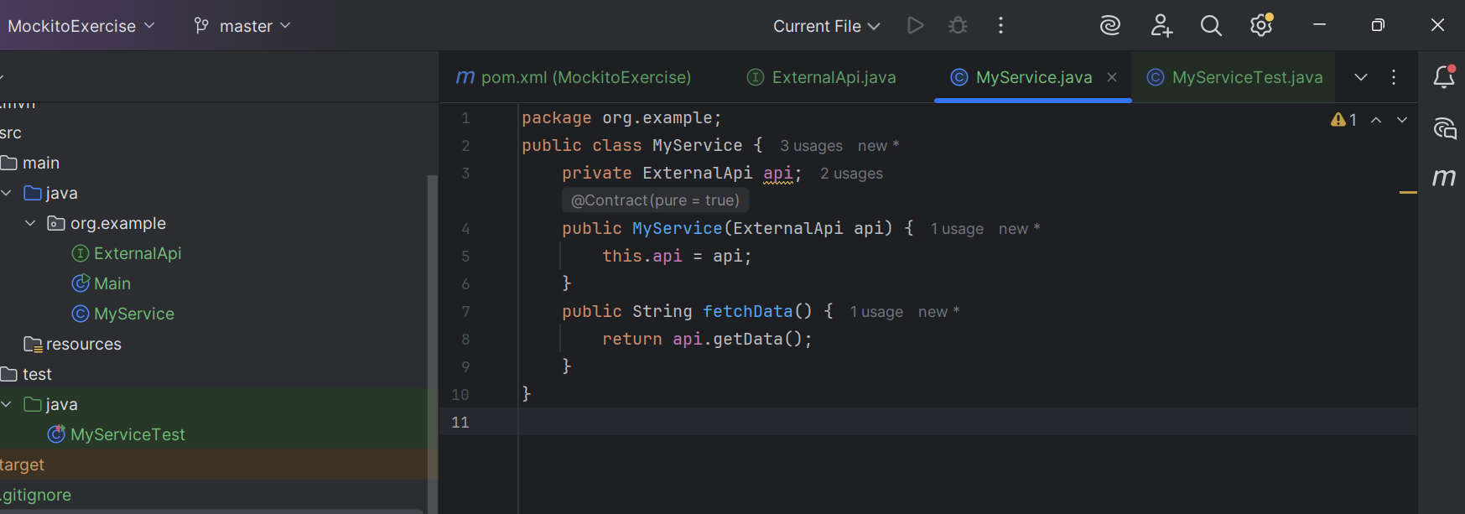
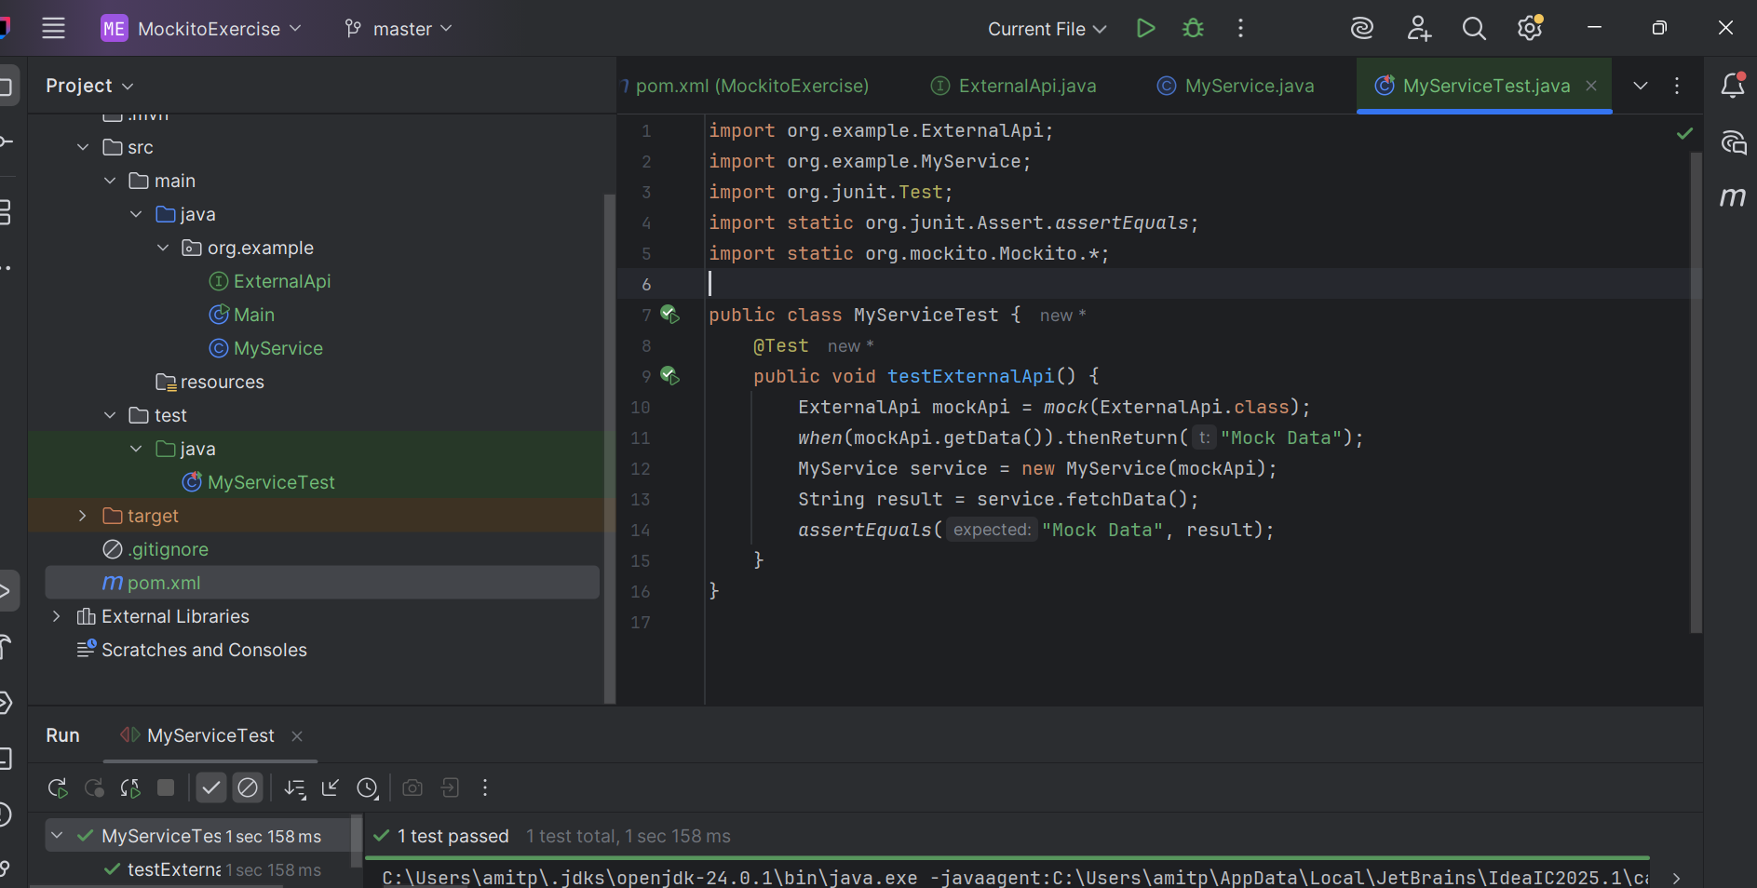
Exercise 2: Verifying Interactions
